Insertando imagen...

ACME-SF

G1.007

**Lint report**

27/05/2024

# Cover

|  |  |
| --- | --- |
| **Repository:** <https://github.com/DP2-C1-07/Acme-SF-D04.git> | |
| **Student #1**  **ID:** 31878881F  **UVUS:**  pabcabmar3  **Name:** Caballero María, Pablo **Roles:** manager, developer , tester | **Student #2**  **ID Number:**49034820Q  **UVUS:** mararnmon  **Name:** Arnáiz Montero, Marco Antonio  **Roles:** developer, operator , tester |
| **Student #3**  **ID Number:** 77865211E  **UVUS:**  alfalolan  **Name:** Alonso Lanzarán, Alfonso Luis  **Roles:** developer, tester | **Student #4**  **ID Number:** 53932912M  **UVUS:** albsanmim  **Name:** Sánchez Mimbrero, Alberto  **Roles:** developer , tester |
| **Student #5**  **ID Number:** 48123111G  **UVUS:** juagarcar4  **Name:** Garcia Carballo, Juan  **Roles:** developer , tester |  |

Table of contents

Cover 2

Executive summary 2

Revision table 3

Introduction 3

Contents 3

Conclusions 3

Bibliography 3

# Executive summary

This document is a lint report. Its purpose is to show the bad smells which may hide potential bugs in the project, if there is any. Otherwise, the “content” section will show the text “intentionally blank”.

# Revision table

|  |  |  |
| --- | --- | --- |
| Number | Date(dd/mm/yyyy) | Description |
| 1.0 | 27/05/2024 | Document done in its entirety, reviewed by peers. No major errors were found. |

# Introduction

The purpose of this document is to provide a detailed lint report of the project “Acme-SF-D04”, for the subject “Design and Testing 2”, regarding the code implemented by student #1. After generating an analysis after launching the SonarLint Eclipse plugin, a list of bad smells was shown, and those related with the work implemented by us were analyzed.

This document has an executive summary, a revision table where there are versioned records, this introduction, the main content, and the conclusions of the report.

# Contents

After launching the SonarLint Eclipse plugin, and opening the “SonarLint Report tab”, we can see one category of bad smell that will be explained:

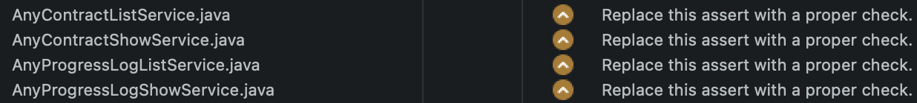

This bad smell is only programming-style related. It can be solved changing the following assertion in the detected classes:

# Conclusions

As we have seen, the bad smell only refer to programming-style related issues, therefore, it won’t hide potential bugs or errors in the project.

# Bibliography

Intentionally blank